Day 3: 18.12.2018
Cleaning of the residential campus of the institute
Swachhata activities for the day started with cleaning of the residential campus of the institute. Various parts of the residential campus were cleaned by the employees of the institute themselves. The importance of keeping one’s residential campus clean was thoroughly discussed among the staff members.
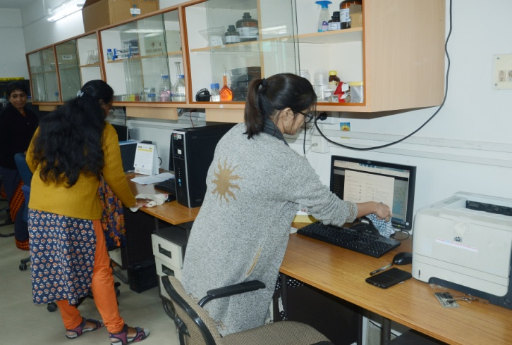
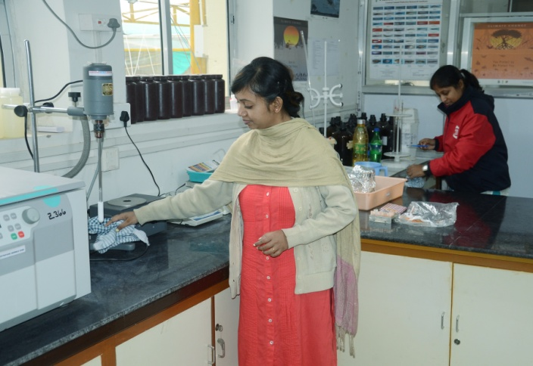
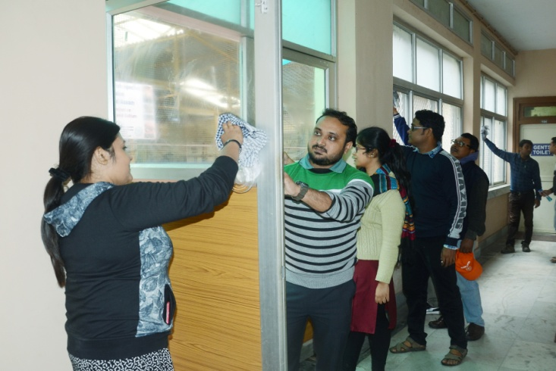
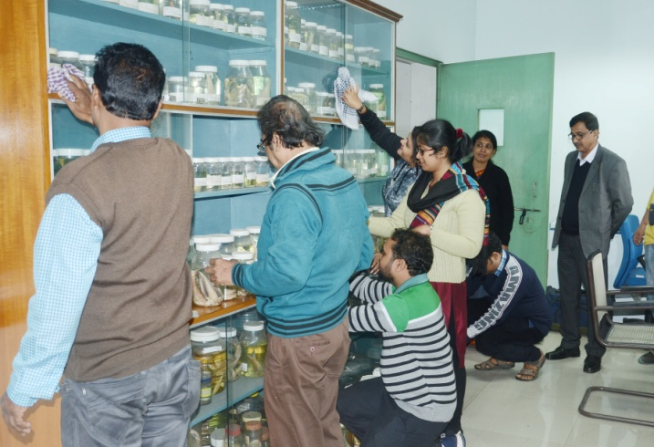

Day 3: 19.12.2018
Cleaning of the lobby, corridors and laboratories of Teesta Building of the institute
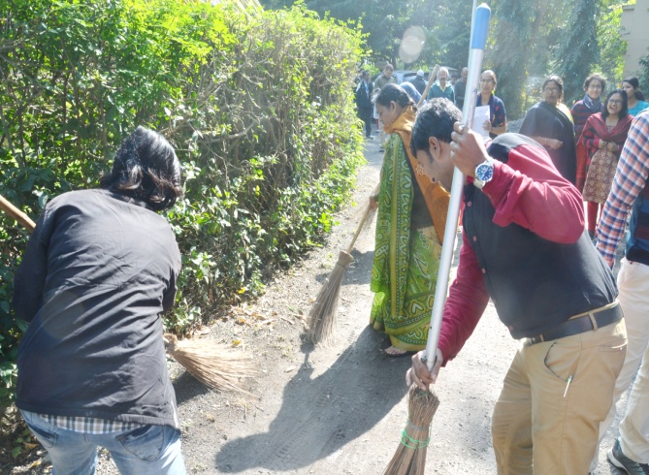
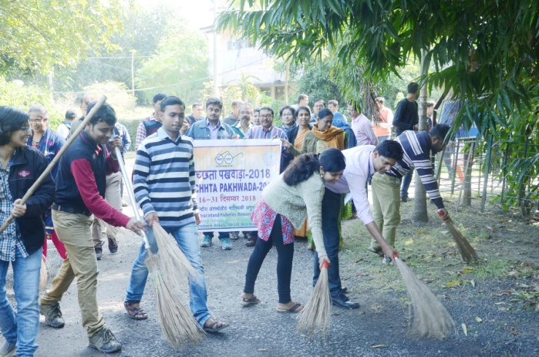
On the third day the staff members got engaged with cleaning of lobby, corridor and laboratories of the Teesta building of the institute. All the institute staff marched together towards the Teesta building of the institute and took part in cleaning several parts of the building. A brief discussion on awareness generation among the staff members followed the cleaning activity.
